Login as SECURITYADMIN (or ACCOUNTADMIN) and create new roles to demonstrate masking policy:

**======================== Creates and Grants ======================**

use role accountadmin;

create role ecommerce_admin;

create role ecommerce_users;

grant usage on warehouse ecommerce_wh to role ecommerce_admin;

grant usage on warehouse ecommerce_wh to role ecommerce_users;

grant ownership on database ecommerce_database to role ecommerce_admin;

grant ownership on schema ecommerce_database.public to role ecommerce_admin;

grant usage on database ecommerce_database to role ecommerce_users;

grant usage on schema ecommerce_database.public to role ecommerce_users;

grant select on table ecommerce_database.public.orders to role ecommerce_admin;

grant select on table ecommerce_database.public.orders to role ecommerce_users;

**============= Checking data before the creation / application of masking policy ===========**

use role ecommerce_admin;

select * from ecommerce_database.public.orders;

You will be able to see the customer_id.

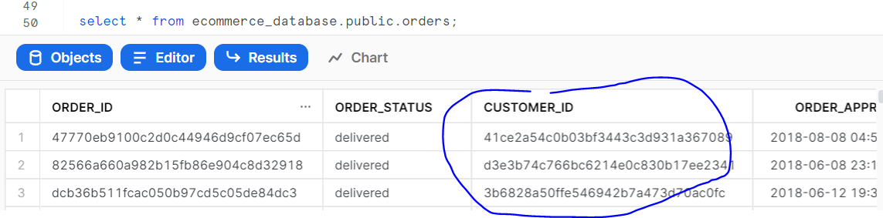

use role ecommerce_users;

select * from ecommerce_database.public.orders;

You will be able to see the customer_id.



**============= Create masking policy and apply on table / column ===============**

create or replace masking policy customer_id_policy

as (val varchar) returns varchar ->

case

when current_role() in ('ECOMMERCE_ADMIN', 'ACCOUNTADMIN') then val

else '#######'

end;

ALTER TABLE IF EXISTS ecommerce_database.public.orders MODIFY COLUMN customer_id

SET MASKING POLICY customer_id_policy;

**============= Checking data after the creation / application of masking policy ===========**

use role ecommerce_admin;

select * from ecommerce_database.public.orders;

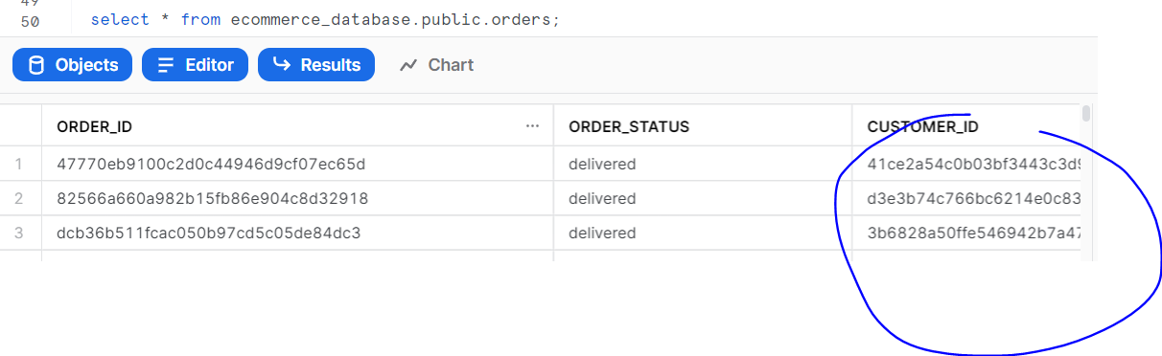use role ecommerce_users;

select * from ecommerce_database.public.orders;

